Assignment -2
IBM CLOUD DB2

Assignment Date | 24 September 2022
Student Name | Madhavan A
Student Roll Number | 722819104071
Maximum Marks | 2 Marks

Question-1: Create User table with user with email,username,roll number, password.
Question-2: Perform UPDATE,DELETE Queries with user table

Question 3: Connect python code to db2.
Question 4 contains 3
Question 4: Create a flask app with registration page, login page and welcome page. By default load the registration page once the user enters all the fields store the data in database and navigate to login page authenticate user username and password. If the user is valid show the welcome page.

App.py
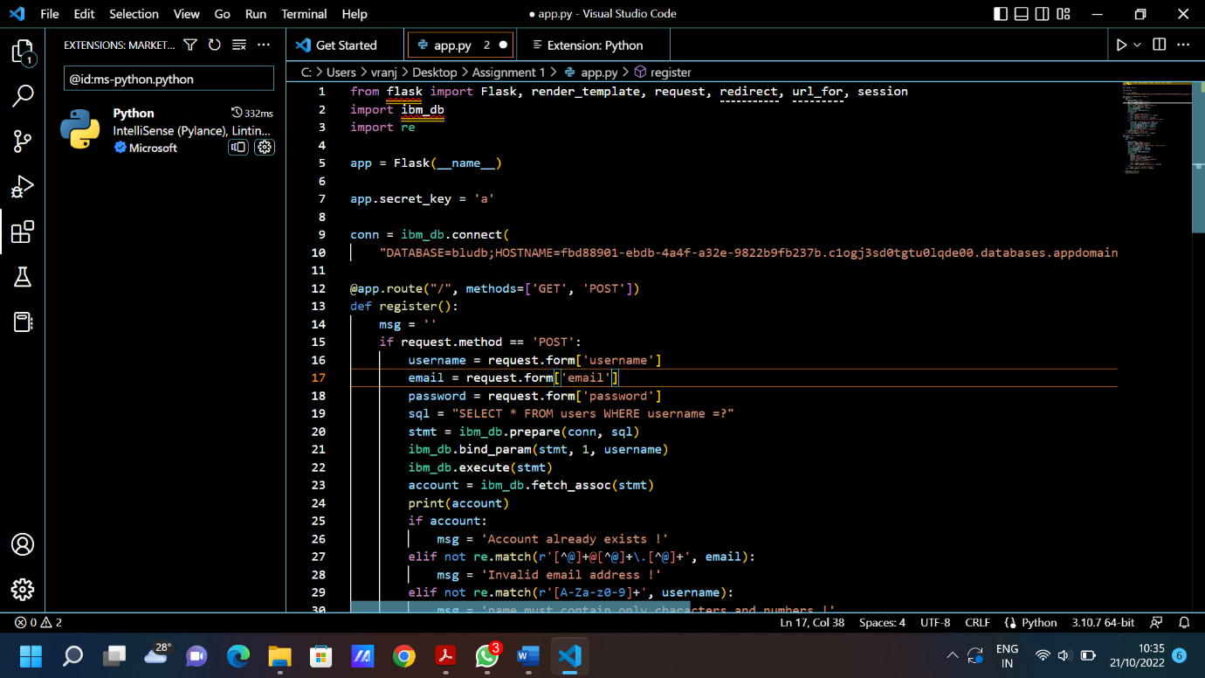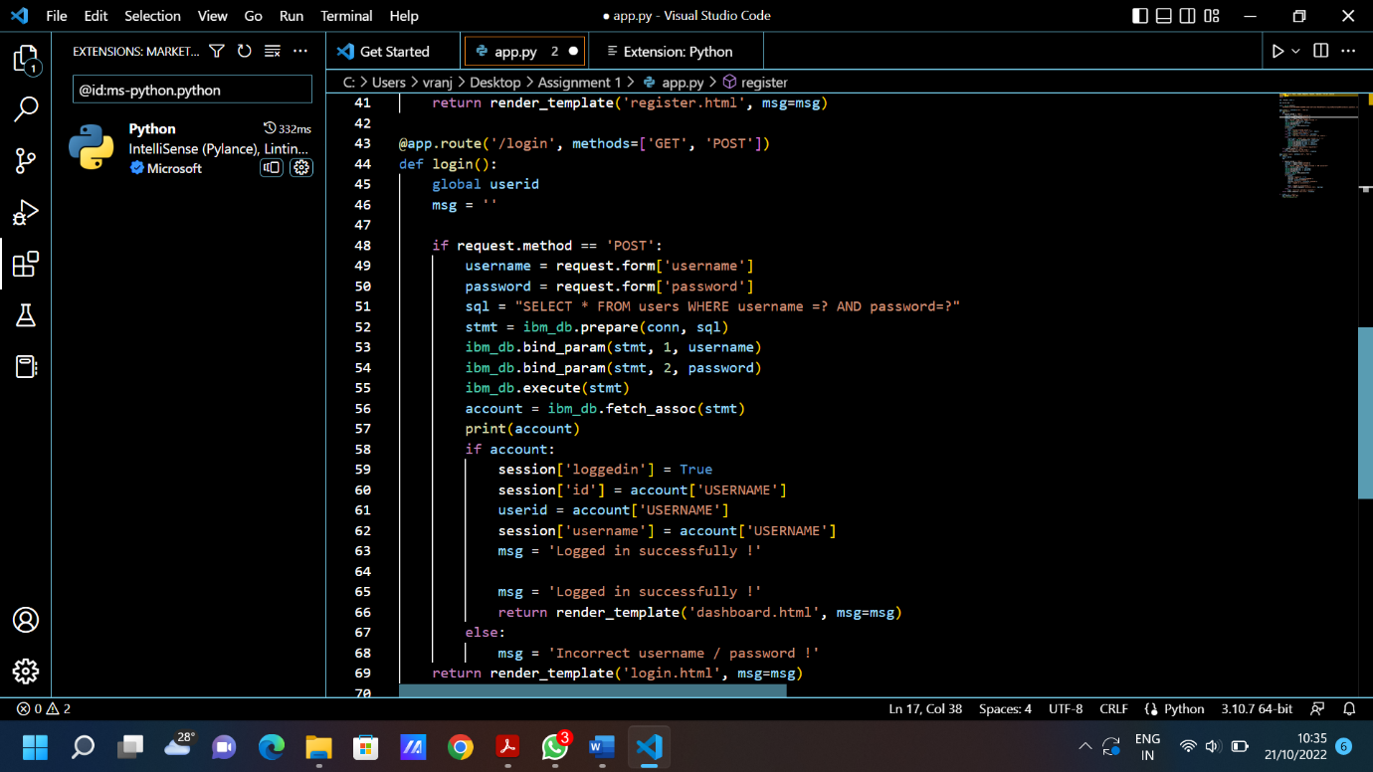

Register.html
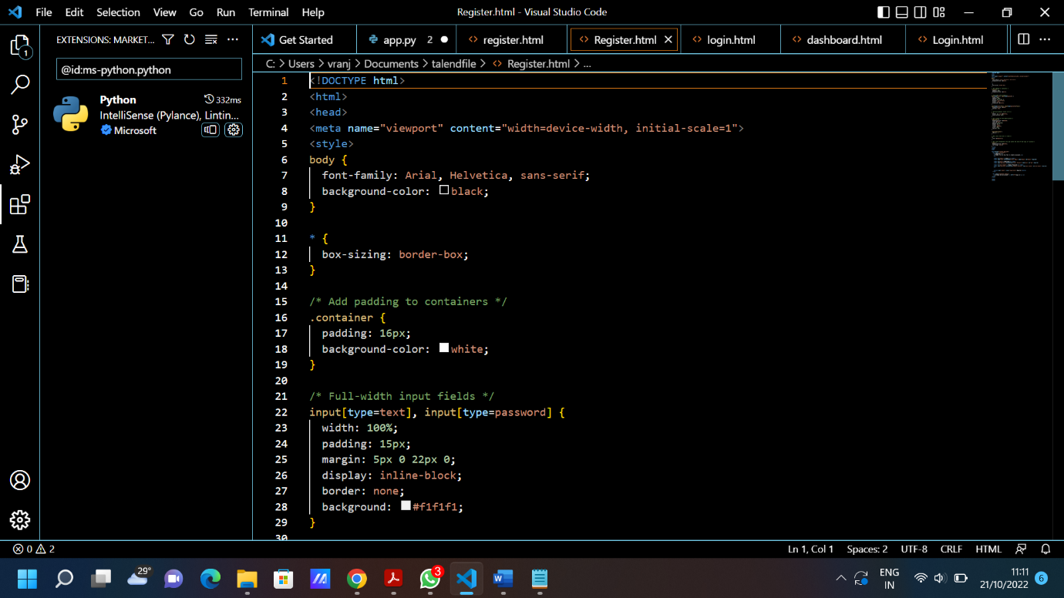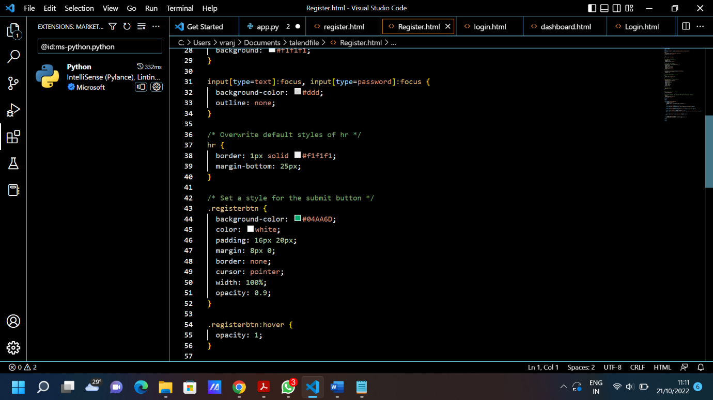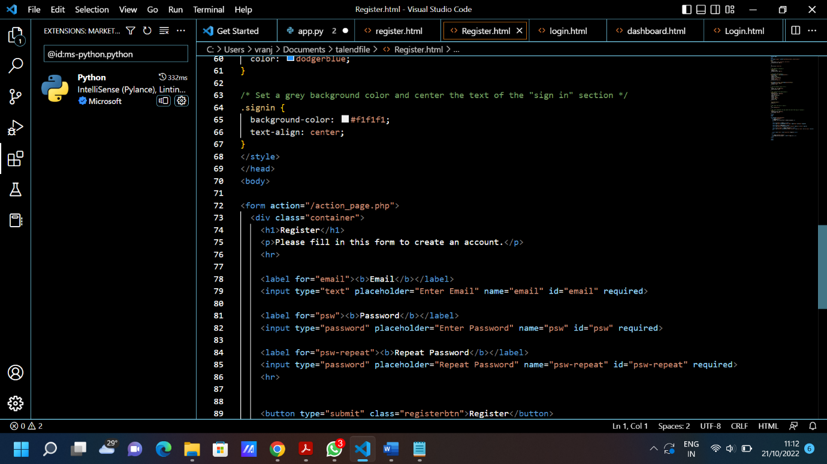

Login.html
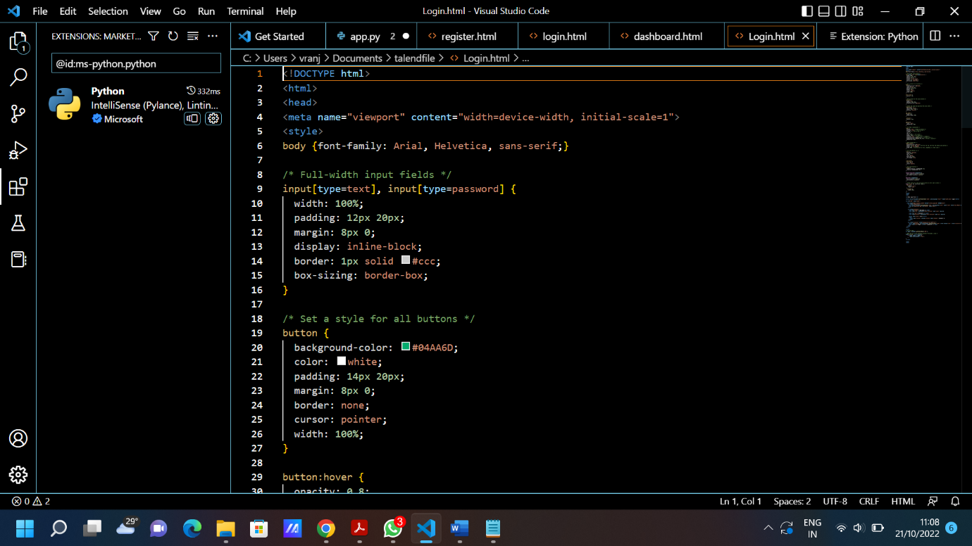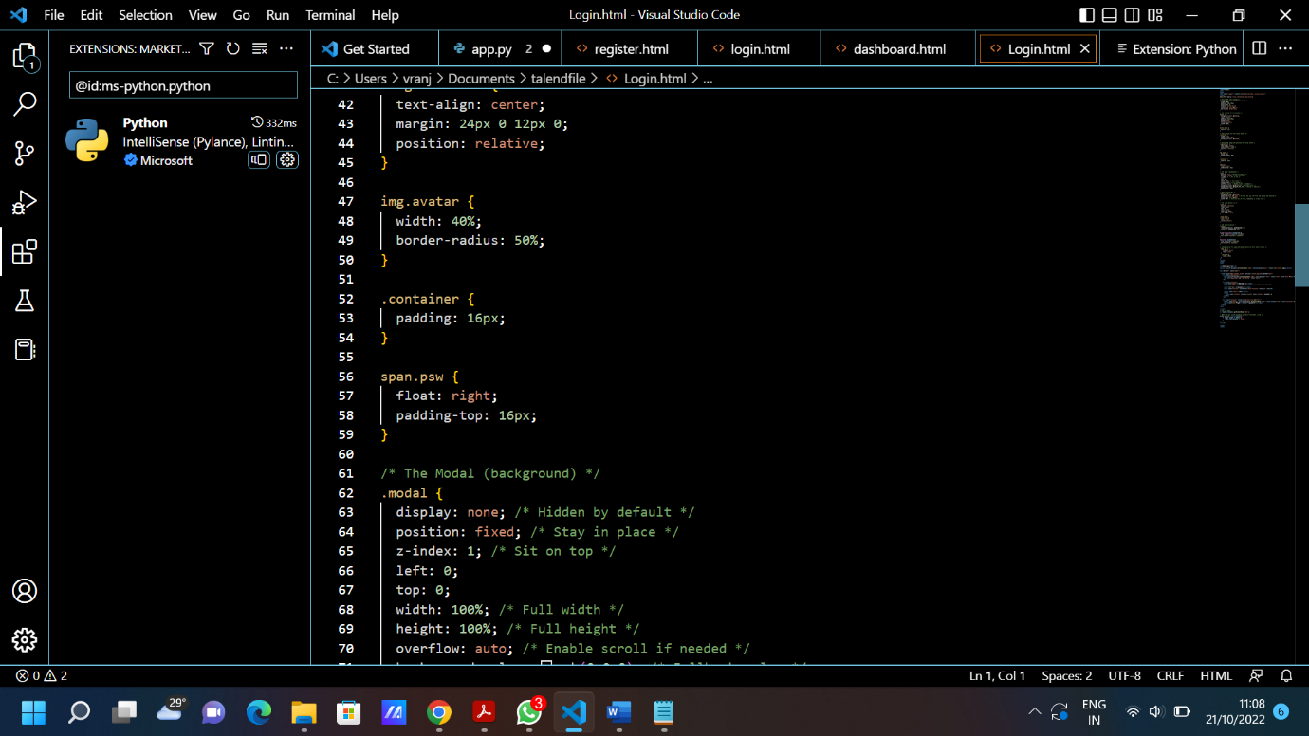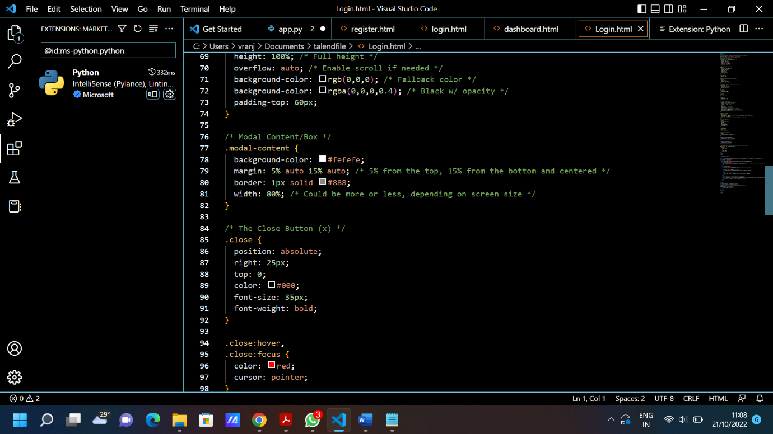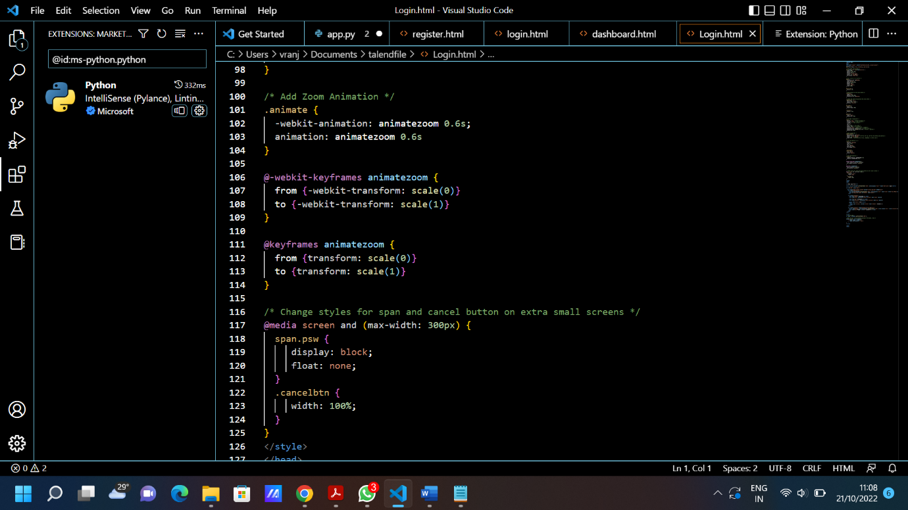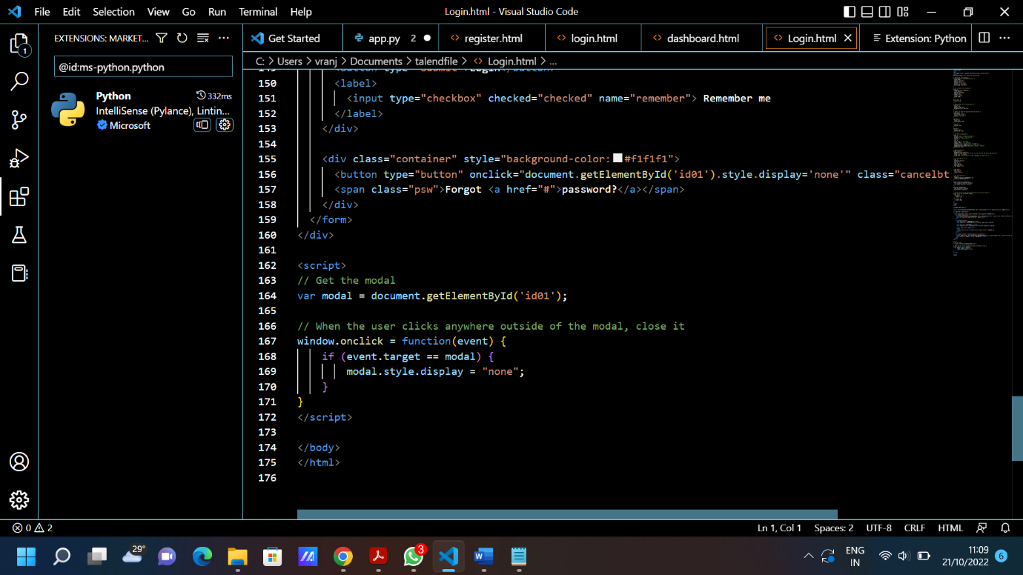

Dashboard.html
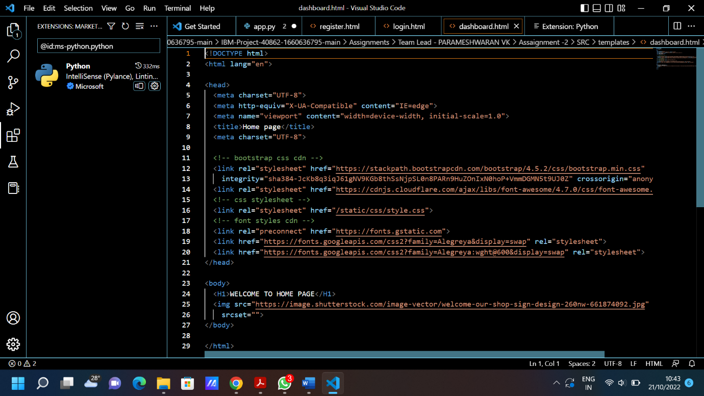

Output:
